Joomla Virtuemart v3.8 Installation Document For Layer Payment

# Step 1

Joomla Extension Installer - Upload & Install plugin zip. Just drag and drop the zip here.

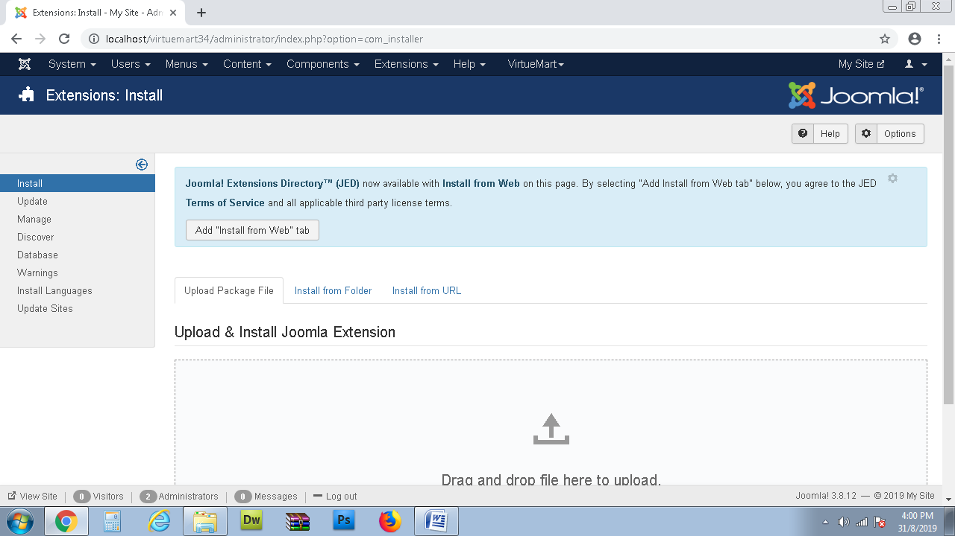

Success response shown

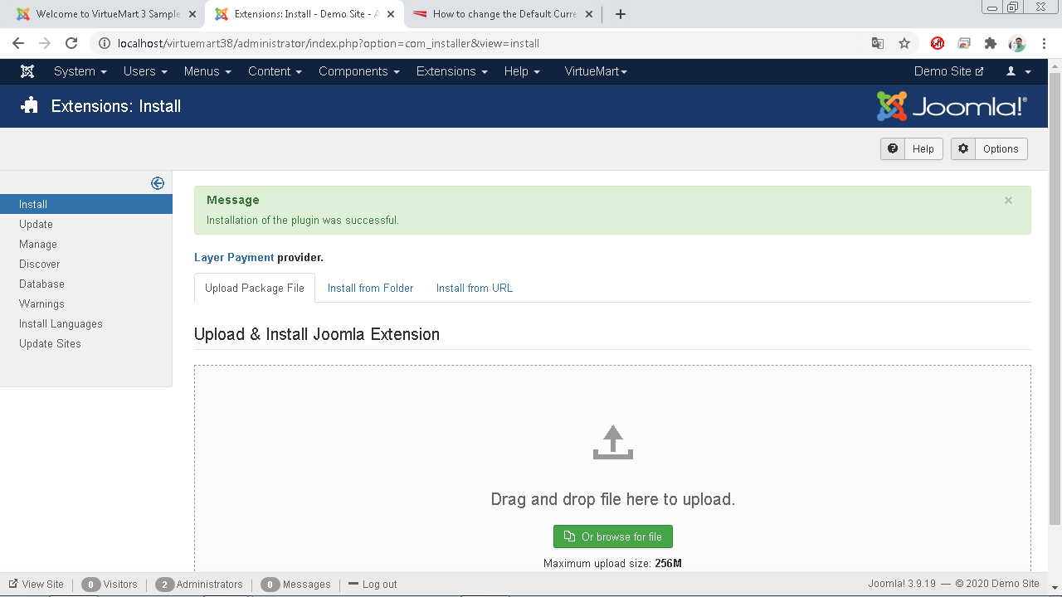

# Step 2

Top Menu goto Extensions -> Plugins and search for “Payment Layer “

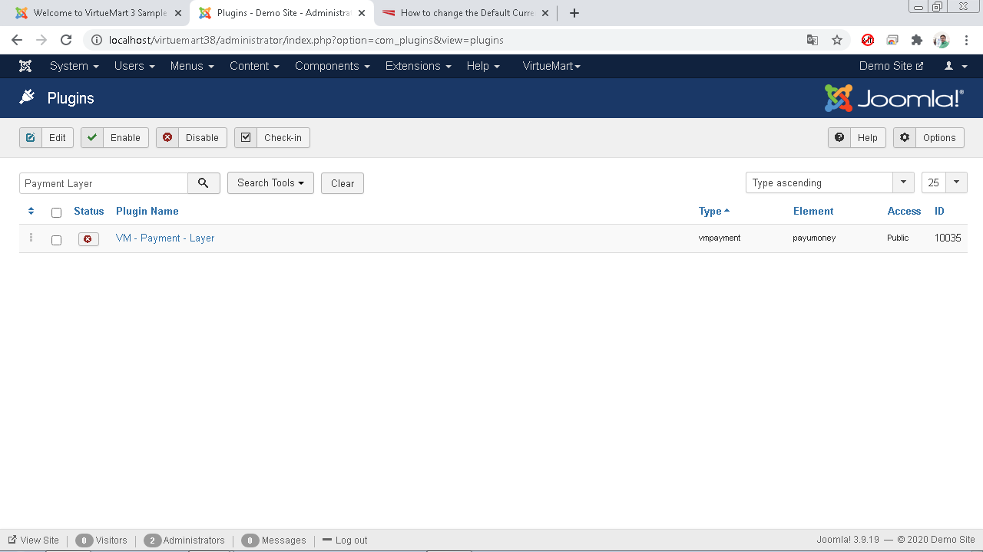

Click on plugin name and Enable it as shown below, finally save the details.

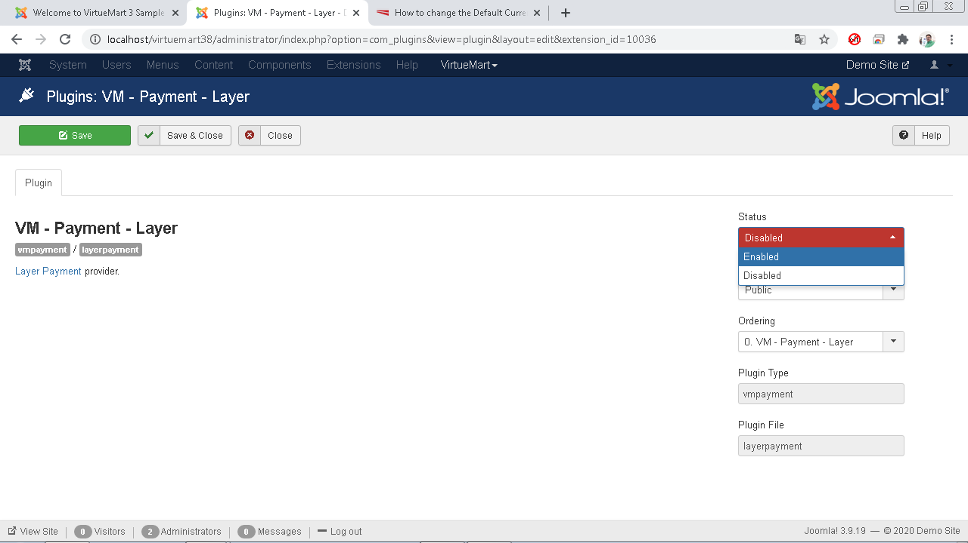

# Step 3

Goto Components - Virtuemart – Payment Methods and Add New.

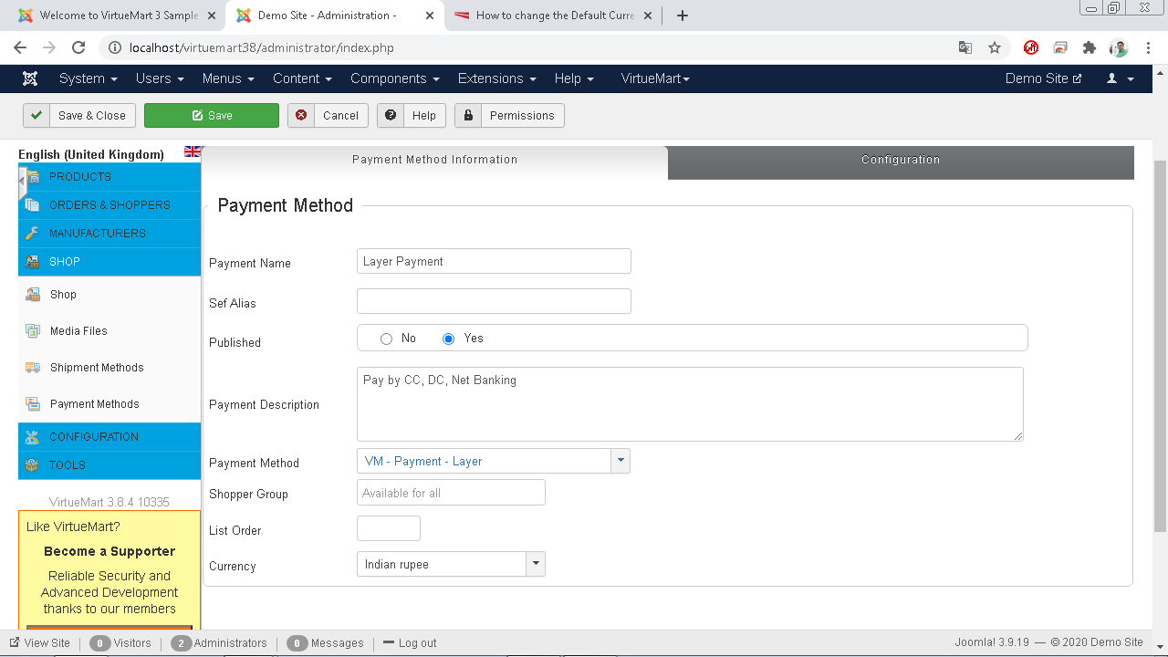

Save and click/goto Configuration on Right.

# Step 4

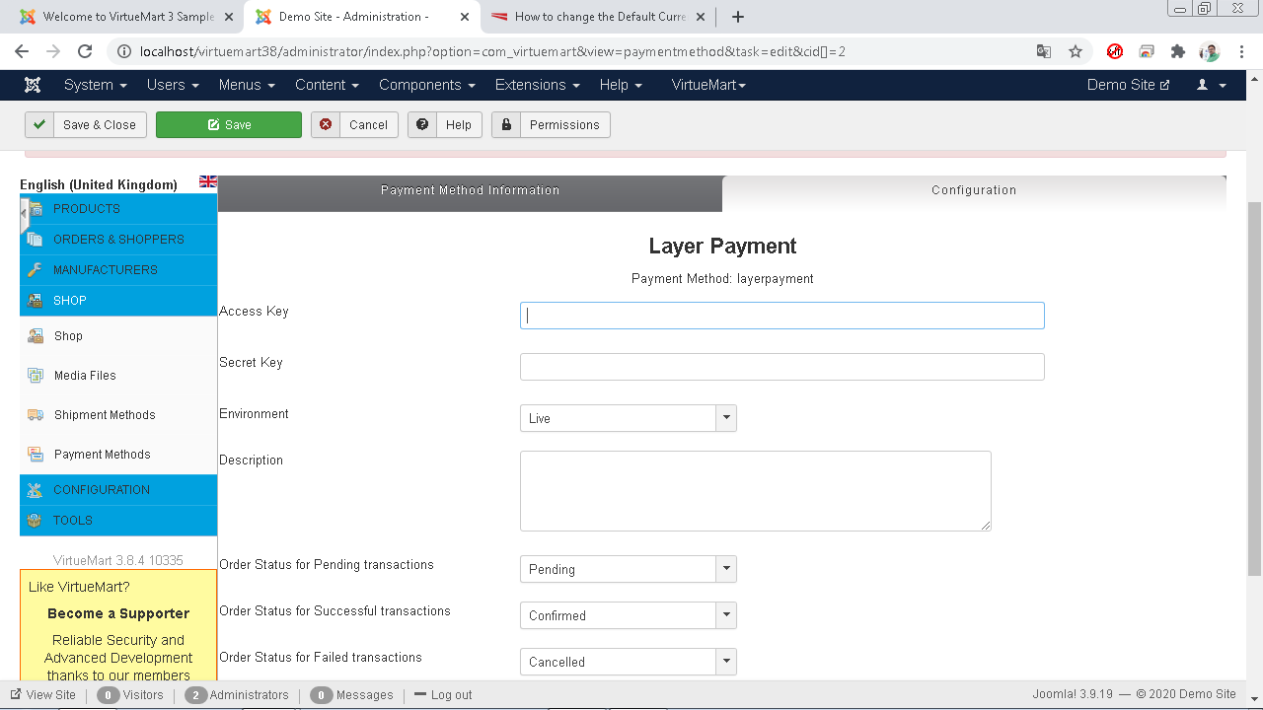

For simple configuration, just enter Access Key and Secret Key and select appropriate Environment (Test or Live).

You may put description as per your choice.

Order statuses are already shown by default. Do not change those unless you are sure.

Finally, Save and Close.

# Step 5

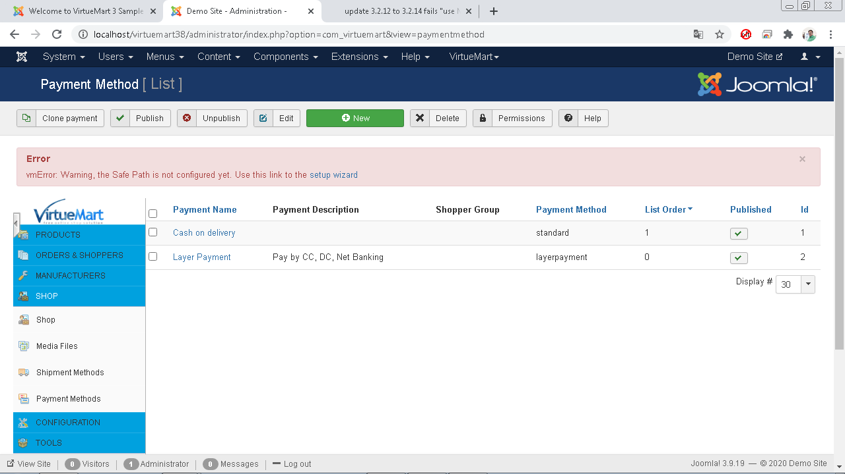

Layer Payment plugin is active. Try checkout.